  - Council Roadside Reserves Project
  - Roadside Vegetation Management Plan Template

Document Tracking
Version No. | Document Author | Reviewed By | Approved By | Last Saved on

Acknowledgements
This document was prepared by Dr Meredith Brainwood, Applied Ecology P/A for local councils in NSW as part of the Local Government NSW (LGNSW) Council Roadside Reserves Project (CRR). The CRR project is funded by the NSW Environmental Trust to build the capacity of councils and to improve the management of roadside environmental values in NSW.
September 2019

Cover: Roadside Reserve in the Warrumbungles LGA (Photo: LGNSW)

This project has been assisted by the New South Wales Government through its Environmental Trust.

Guide to this document
This template is designed to guide councils in the development of a Roadside Vegetation Management Plan (RVMP). It forms part of the guidance materials developed through the Council Roadside Reserves Project, funded by the NSW Environmental Trust. The template is for guidance purposes only and the reader should undertake their own review of legislative changes and application to specific council circumstances. Council may adapt this template with citation as required.
The intention is that land managers will work directly into a copy of this template. Instructions and prompts are in grey text boxes. These should be deleted as you work through the template. The text in red is for guidance purposes only. Additional background and guidance information is provided in green text boxes.

Background to the RVMP template
A RVMP is a mechanism to coordinate strategic management of roadside vegetation across the LGA. A robust RVMP will define the management principles that guide actions within the roadside areas and are consistent with corporate objectives and legislative requirements.
Legislation also triggers a risk management approach where processes are required to support strategic planning and on ground works, such as preliminary environmental assessments, Review of Environmental Factor’s (REF’s), Part 5 assessments, checklists and points of reference. Risk management is already well established for occupational health and safety and financial responsibilities. Many councils are developing or have developed a risk management approach to climate change impacts, which is relevant to the management of roadside environments and should be considered in the preparation of the RVMP.
The plan communicates management requirements to internal council staff and to external roadside users including adjacent landholders. The consultative process recommended in developing a RVMP also becomes an engagement tool for staff from different sections to assist in delivering the plan. The management actions within the RVMP should identify the action priority, timing, responsibility and resourcing. This can be linked to councils Delivery Plan and Operational Plan.
Monitoring progress of the actions and progress towards council’s goals for roadsides is an important facet of administering a RVMP. By linking the plan to councils IP&R process there will be accountability for annual reporting and end of term reviews.

Underlying assumptions
This template is designed to be used by councils without an existing RVMP, or that need to completely revise their old RVMP to comply with new legislation or add new assessment data.
Preparation of roadside vegetation community distribution and condition mapping is required to underpin the preparation of the RVMP.
The RVMP can be developed to apply to all the roads within an LGA, or a subset of roads. This needs to be clearly identified and specified at the start of the plan. For example, council may decide to create a subset of roads that have good quality vegetation and develop the RVMP to apply to those areas. Alternately, councils may decide to map key assets as they understand them, but develop an RVMP that can be applied more generally to the whole of the LGA.
It should be noted that surveys that include a subset of roads may miss key assets and/or key problems that are also within council’s management obligations. The actual extent of vegetation surveys and condition assessment needs to be clearly stated in the RVMP, with maps to provide detail about which areas were assessed, and which weren’t.
Identification of vegetation communities and assessment of vegetation condition are specialised tasks. Many councils have experienced staff that can undertake vegetation mapping and condition assessment, although this may require a considerable allocation of time and resources.
Councils may be able to build on existing vegetation mapping or undertake surveys themselves using the RAM (Rapid Assessment Methodology), alternatively they may engage a suitably qualified and experienced consultant to undertake the surveys on their behalf. The RVMP can then be prepared by council based on the results of the surveys, or by a consultant to meet council’s requirements.
Councils are strongly encouraged to ‘personalise’ the information in the RVMP template, especially when they have an existing ‘style’ for management plans and other documentation. This will help to foster a sense of ownership of the plan and the required management of roadside vegetation.
Councils may also have local issues that need to be addressed, which may not be itemised in this RVMP template. For example, some LGAs need to develop and maintain flood or fire evacuation routes, and the roadside vegetation on these roads may need to be managed differently. Additional sections or subsections should be added to the plan to cover the management of these issues.
It is important to understand where the RVMP will fit within council’s wider management responsibilities. At all times the safety of the travelling public has primary importance. Once this has been considered, for roads in non-urban areas the next level of management needs to protect the natural environment in accordance with the legislation outlined in this RVMP template.

Insert logo

Council Name

Roadside Vegetation Management Plan (RVMP)

Prepared by:

Date:

Contents
1. Background 6
2. Vision 7
3. Objectives 8
4. Relevant Legislation 9
5. Links with Council Systems and Planning (IP&R) 11
6. Description of Roadside Vegetation and Other Environmental Values 13
7. Local Roadside Environmental Management Threats and Issues 15
8. Community Interests, Values and Activities 18
9. Conservation Values 19
10. Roadside Environmental Management Priority Sites 24
11. Management Action Plan 26
12. Monitoring and Evaluation 35

Background
Briefly describe the reason(s) that this RVMP has been prepared. This helps to acknowledge the importance of the RVMP.
For example:
‘This plan will assist Council to manage vegetation within the roadside reserve, particularly areas with moderate to high conservation value. The intention of this RVMP (Roadside Vegetation Management Plan) is to provide Council with an easy to use resource which identifies values, issues and appropriate actions to manage the roadside reserve at both the organisational and roadside level.’ (Penrith City Council)

Vision
The vision of the plan should be briefly stated in terms of what state it is trying to achieve in the future.
Examples of a vision statement include:
  - ‘Improved management of the roadside environment to achieve a safe, functional road network which contributes to ecological preservation and community values of the Local Government Area.’ (Bellingen Shire Council)
  - ‘Council is committed to work with the community and relevant stakeholders to create a network of road reserves that provide a safe environment for vehicle movement while recognising and protecting the conservation, landscape, cultural and recreation values of rural roadsides and vegetation.’ (Parkes Shire Council)

Objectives
The objectives of the plan should be clearly stated.
For example:
  - ‘Provide clear direction in the protection and management of roadside vegetation, as well as provide recommendations to enhance the structural composition of current vegetation conditions.
  - Provide baseline information to alert Council of its legal obligations regarding native vegetation, ecologically endangered communities, threatened species (both flora and fauna), and biodiversity conservation.
  - Provide essential information to non-environmental staff regarding the value and significance of roadside vegetation, its appropriate management and the implications this has on all Council operations.’ (Lockhart Shire Council)

Objectives can be quite specific as well, for example:
  - ‘Minimise any biodiversity impact of current weed control practices in roadside reserves that have ‘high’ and ‘medium’ conservation value
  - Identify priority weed management actions that protect and enhance the condition and environmental values of roadside environments, particularly those with 'high' conservation significance
  - Shift the focus from the control of priority weed species to broader site management goals
  - Better integrate roadside vegetation management with existing Council planning mechanisms including the 10-year Business Activity Strategic Plan, 4-year Delivery Plan and annual Operational Plan.’ (Hawkesbury River County Council)

Relevant Legislation
There is a wide range of legislation and policies that apply to the management of roadside vegetation. Refer to Council Roadside Environmental Management Framework for guidance. Relevant legislation may include (delete any that are not relevant to your LGA):
Commonwealth:
  - Environment Protection & Biodiversity Conservation Act 1999
State:
  - Environmental Planning and Assessment Act 1979
  - Biodiversity Conservation Act 2016
  - Fisheries Management Act 1994
  - Protection of the Environment Operations Act 1997
  - Contaminated Land Management Act 1997
  - Water Management Act 2000
  - Rural Fires Act 1997
  - Roads Act 1993
  - Heritage Act 1997
  - National Parks and Wildlife Act 1974
  - Biosecurity Act 2015
  - Local Government Act 1993
  - Rural Lands Protection Act 1998
  - Coastal Management Act 2016
  - State Environmental Planning Policy (Infrastructure) 2007
  - State Environmental Planning Policy (Koala Habitat Protection) 2019
Local Government:
  - Local Environmental Plan (LEP)
  - Development Control Plans (DCPs)
  - Community Strategic Plan
  - Delivery Program
  - Operational Plan
  - Biodiversity Management Plan
  - Transport Asset Management Plan
  - Natural Asset Plan
  - Regional Plans
It is important to understand exactly how each piece of legislation, policy or plan applies to the management of roadside vegetation. For example, the Koala Habitat Protection SEPP may not apply in your LGA. For peri-urban councils, The State Environmental Planning Policy (Vegetation in Non-Rural Areas) 2017 may apply on some roads. The relevant information from each act, policy and plan should be summarised in a table in the RVMP or as an appendix to the plan. This reflects the current application of the legislation and can be checked at a later date to ensure ongoing compliance with legislative requirements.

Links with Council Systems and Planning (IP&R)
!
Be sure you know what systems your council has in place as there may be other plans or policies that are relevant.

Provide a brief statement or list. Ensure it is clear where the RVMP sits with other council plans and systems. Identify the relevant environmental objectives in the Community Strategic Plan and include a statement(s) and/or flow chart showing how RVMP actions will be incorporated into councils’ asset management plans and delivery program, which allocate budgets for the delivery of works and services on roadsides.
The RVMP needs to coordinate with some or all the following systems and plans:
  - Delivery Plan (4 years)
  - Operational Plan (1 year)
  - Resourcing Strategy, including Long Term Financial Plan
  - Strategic Asset Management Plan
  - Risk Management Plan
  - Regional Strategic Weed Management Plan
  - Stock Movement and Grazing Policy
  - Collection of Firewood Policy
  - Engineering Project Management Plans
  - Local grant applications

The following figure provides an example of how an RVMP fits with Council’s IP&R framework:
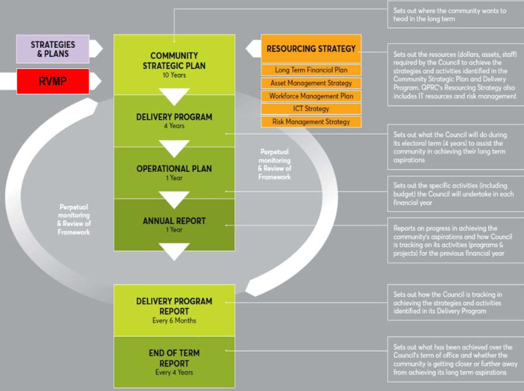
(from Queanbeyan-Palerang Regional Council RVMP)
7

Description of Roadside Vegetation and Other Environmental Values
Use the results of the roadside environmental assessments to provide a description of the diversity and values of roadside environments in the LGA. The description should be accompanied by photographs and include maps where possible. This information can be included in the body of the plan, or as an appendix with a summary in the body of the plan.
This section should include a description and photos (where available) of:
  - Endangered Ecological Communities found in the LGA, and/or found in roadside vegetation (for LGAs with whole of shire vegetation mapping)
  - Threatened flora species and their locations in roadside vegetation
  - Threatened fauna species and their habitat requirements

Information on the vegetation communities likely to be present can be found on the SEED (Sharing and Enabling Environmental Data) portal https://www.seed.nsw.gov.au/. With SEED, you can search for environmental data and view it on the built-in map.
You can overlay different types of data to gain a more complete picture of environmental conditions in a particular location. SEED also provides resources that assist you to understand the data, and links to the data in various formats should you wish to download it. There are two ways to access data:
- Via the interactive map, which allows you to choose your location and find what datasets are available in that area https://geo.seed.nsw.gov.au/Public_Viewer/index.html?viewer=Public_Viewer&locale=en-AU
- Via the dataset catalogue, which allows you to choose the dataset of interest and view it on the interactive map https://datasets.seed.nsw.gov.au/dataset
SEED comes with a very useful help page https://www.seed.nsw.gov.au/need-help with information about how to access the data of interest and links to additional information.
Information about threatened species and threatened communities protected in NSW under the Biodiversity Conservation Act 2016 can be found by searching the BioNet website: https://www.environment.nsw.gov.au/atlaspublicapp/UI_Modules/ATLAS_/AtlasSearch.aspx
Select the area you want to know about at #3. Use “Select a geographic area” and then select “LGA” from the dropdown menu. This will allow you to pick your LGA.
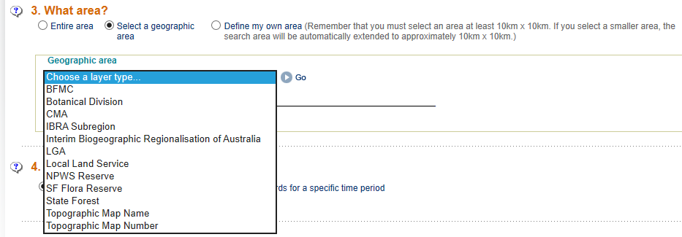
.
Use the Protected Matters Search Tool to check for additional species and/or Ecological Communities that are listed under the Commonwealth Environment Protection & Biodiversity Conservation Act 1999.
Then use the ‘Interactive Map Tool’ to search the desired area or ‘Report by Region’ to search throughout your LGA. Enter your email address and the report will normally be emailed to you almost immediately.
Refer to or include other records of natural environmental assets in the LGA, for example, observations recorded by local birdwatchers and naturalist clubs, etc. Compiling all this information can provide a good start to a comprehensive register of natural assets for the LGA.

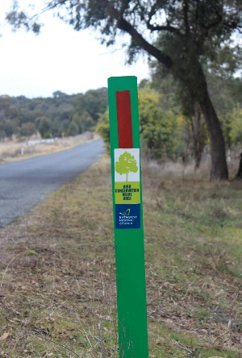
You may also want to include additional information about natural environmental assets in the LGA. For example, many LGAs have signage that show the location of high quality bushland areas.
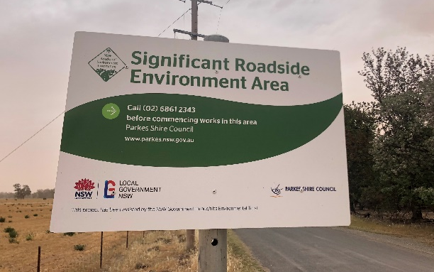
Significant Roadside Environment Area signage is an initiative of the Roadside Environment Committee.

Local Roadside Environmental Management Threats and Issues
!
Threats can be different in different areas, and can be due to direct impacts, such as littering and unauthorised clearing, or indirect impacts such as bushrock removal. Some result from activities undertaken by council staff or other authorised workers, and others by members of the public.
Describe the threats and issues impacting on local roadside environments and how these could be minimised or resolved.
The following is a list of common threats to roadside vegetation. Remember to add or remove those relevant to your LGA.

Construction and maintenance activities:
  - Construction and maintenance of roads
  - Uncontrolled maintenance of roads by landholders
  - Maintenance of utilities, especially clearing under power lines
  - Clearing for fencing construction
  - Clearing for sight lines around property gates, creation of ‘gardens’
  - Firebreak construction, especially in the road reserve
  - Stockpiles
Other activities:
  - Weed invasion – can occur through movement of plant and machinery, or by wind and water
  - Soil removal, especially topsoil removed by scraping roadsides around orchards
  - Bush rock removal, a key threatening process (BC Act)
  - Firewood collection on roadsides, a key threatening process (BC Act)
  - Unauthorised clearing – clearing is regulated by Local Land Services in rural areas except on roadsides. Roadside vegetation is under the care and control of council, and approval is required before any clearing can be conducted on this land
  - Unauthorised grazing – grazing on public land requires a permit from Local Land Services
  - Burning off – kills plants and animals, and can reduce biodiversity in the long term if not done properly
  - ‘Tidying up’ – animals need complexity in their habitat, such as fallen timber, rocks, plants of different sizes and textures, so these need to be left where they are
  - Dumping rubbish, including household waste, building materials, old fencing material, green waste, etc
Management issues arise when there is a conflict between different uses or desired management outcomes.
(For more information see the Roadside Environment Committee’s Factsheet #2 – managing roadsides: planning).
Main issues include:
- Road safety – includes tree removal for clear zones, which may result in loss of biodiversity and ecosystem function values.
Austroads provides guidelines for clear zones in rural and urban environments. A RMS supplement to the Austroads guide is also available, which states that “In NSW the clear zone principle is used.” And that “In NSW all hazards identified in the clear zone should have treatment (e.g. removal, protection).”
NSW RMS Landscape Design Guideline is also available to assist councils to improve the quality, safety and cost effectiveness of green infrastructure in road corridors. This design guideline recognises the values of roadside vegetation and provides information about how to maintain this resource in a cost-effective manner. Section 3.3 deals with Safety considerations - clear zones, public utilities, sight distances and vegetation types.
- New road construction and widening – may require the removal of native vegetation. This may trigger the need for a Review of Environmental Factors (REF) before proceeding.
Refer to the REF Templates for guidance
- Fire management – roads and vegetation in linear reserves are important for bushfire management. Linear reserves are covered by local Bushfire Risk Management Plans (BFRMPs) prepared by the NSW Rural Fire Service.
A BFRMP is a comprehensive document that maps and describes the level of bush fire risk across an area. These are usually prepared on a regional basis and can be downloaded from the RFS website.
- Weed management – Weeds are the second greatest threat to biodiversity after habitat loss (clearing). Roadside vegetation is particularly vulnerable to weed invasion.
!
Local control authorities are responsible for enforcing the control of priority (formerly noxious) weeds on private lands and for undertaking weed control measures on council managed lands including roadside reserves. In some areas, Council is the weed control authority, elsewhere it may be a regional organisation that operates across several LGAs

.
Information on managing weeds in roadside reserves can be obtained from:
  - Weed management on roads
  - Australian Weeds Strategy 2017-2027 - aims to prevent new weed problems and reduce the impact of existing weeds of national significance.
  - NSW Invasive Species Plan 2018-2021 - Provides a framework for the management of weeds and pest invertebrates and animals NSW.
  - WeedWise
  - Regional Strategic Weed Management Plans 2017-2022 – outlines goals for weed management in the region. Prepared by Local Land Services for each region
- Inappropriate activities by landholders, such as littering, illegal dumping, firewood collection, illegal grazing and clearing by adjacent landholders can impact roadside vegetation.
These can be managed through the development of a Council Roadside Vegetation Management Policy, and residents can be informed about their responsibilities through a landholders/rate payers information mailout, or similar.
- Climate change – The climate of NSW is changing. Average temperatures have been rising since the 1960s. Climate change will exacerbate natural variability, making it more difficult to manage landscapes and ecosystems. Remnants of vegetation such as linear reserves will be particularly vulnerable.
NSW is expected to become hotter, with the greatest increases in temperature expected to occur in the north and west of the state. North-eastern NSW is likely to experience a slight increase in summer rainfall, while in the south-western regions there is likely to be a decline in winter rainfall.
Many parts of the state will experience a shift from winter dominated to summer-dominated rainfall. Roadside corridors will be particularly vulnerable, but increasingly important due to the way they act as dispersal corridors across a fragmented landscape.
For more information on climate change in NSW see DPIE website.

Community Interests, Values and Activities
Describe the community interests, values and activities relating to local roadside environments and how these could be acknowledged and changed if required. This may require community education to increase awareness or change current behaviours.
Opportunities for community education include:
  - Local newspapers and radio to highlight positive outcomes
  - Sensitive Roadside Environment Area (SREA) signs and road markers
  - Advertising through rate notices and council publications
  - Pamphlets
  - Maps
  - Use of social media, including council’s Facebook and Twitter
  - Content on council and stakeholder websites
  - Presentations to community groups and schools.
Birdwatching and field naturalist clubs will have an interest in the biodiversity values of roadside vegetation in the area.
Community groups or local businesses can be encouraged to contribute to the maintenance of roadsides through an ‘Adopt-a-road’ scheme. The Adopt-a-road scheme is managed by local councils on an individual basis. Hawkesbury City Council have prepared a manual that describes how the scheme works in their LGA.
Private businesses, schools and community groups can be involved in tree planting, weeding, litter removal or other activities on roadsides. Organisations such as Greening Australia, Landcare, Local Land Services, Clean Up Australia and Keep Australia Beautiful have expertise in getting the community involved.
In some regions, Local Land Services have provided grants to neighbouring landholders to undertake works to extend or complement the conservation value of roadside vegetation (for example Mid-Western Regional Council).

Conservation Values
Describe the extent of high, medium and low conservation value roadsides using maps.
This section should include a description of vegetation condition classes:
  - Low Conservation Value (LCV)
  - Medium Conservation Value (MCV)
  - High Conservation Value (HCV)

Data sources include council’s geographical information system and field surveys, including using the Rapid Assessment Methodology (RAM) tool developed through the Council Roadside Reserves project.
Roadside vegetation community distribution and condition mapping is best determined through a combination of field surveys and desktop review of vegetation mapping and biodiversity databases.

Include a brief description of the methods used to assess and map conservation values in your LGA.
Include location(s) and photos of local examples of the different vegetation condition classes.

The “traffic light system” of colour coding for conservation value mapping for roadside vegetation, is used widely throughout NSW. The following key explains the different codes:
  - LCV = GREEN (go about your normal work activities)
  - MCV = YELLOW/AMBER (proceed with caution as there may be additional environmental considerations)
  - HCV = RED (stop what you are doing and check for environmental assets identified in this area)

! | The RAM enables land managers to assess the conservation value of many sites in a relatively short time frame and to collate and compare them with other sites. It provides a simple approach to assess and capture environmental data, through a two page proforma that identifies three main aspects: conservation status, landscape context and vegetation condition. Based on the scoring for each of these aspects and using a conservation value assessment matrix, each site is then assigned an overall conservation value of high, medium or low. Councils can then use this information to prioritise and manage their roadside reserves, further detail is provided in the RAM Guide.
 |  | The RAM training package and guidelines have been developed to assist with statewide consistency. The guidelines will be supplemented by regional vegetation guides that provide an overview and summary of the key vegetation classes and associated Threatened Ecological Communities that are known to occur within each LLS region.
Two RAM Apps have been developed to assist councils and LLS staff in undertaking their assessments. The Apps provide an in-field tool to collect data in an electronic format, bypassing the need for using field sheets and therefore the possibility for transcription errors.
 |  | The EcoRoadside App has been developed for councils by EcoServer. The App provides a visual guide with prompts and information to assist councils in filling out the RAM form. Photos and additional information can be recorded including current and proposed management requirements. The final conservation value score is calculated on-site enabling a ‘live’ in-field check. Guidelines for setting up and using the EcoRoadside App are available along with an introductory set up video and detailed training videos.
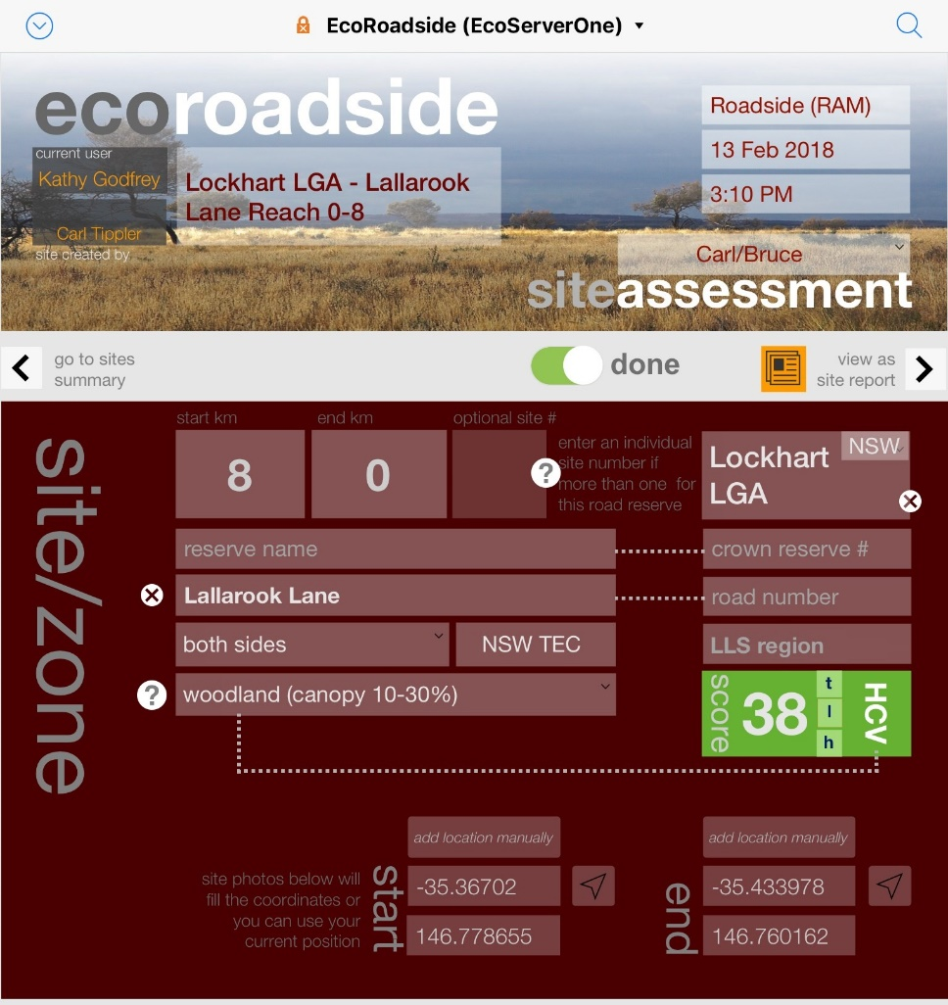
! | The ESRI Collector for ArcGIS application (app) was developed for LLS and is also available for use by councils. The ArcCollector App requires pre-loaded assessment points that have pre-populated landscape information for the sites. This App requires an ArcGIS named user account, those interested in using this App should contact their local LLS office.
Add an overview map showing where the different categories of vegetation are located within the LGA.
You can also add other information to the mapping to build up a better picture of roadside environmental values (see Lithgow example).

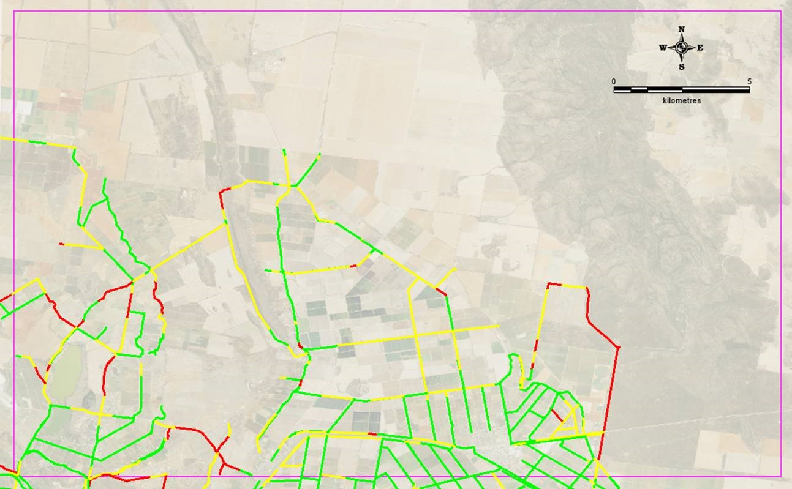
RED = HIGH CV
YELLOW = MEDIUM CV
GREEN = LOW CV
(example from Griffith City Council’s RVMP)

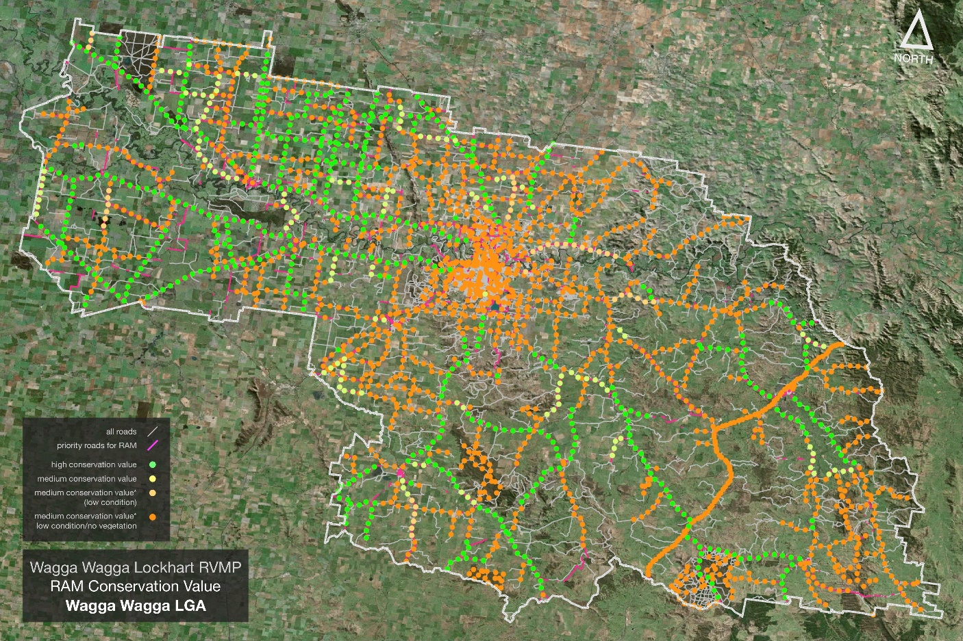(example from Wagga Wagga City Council’s RVMP)
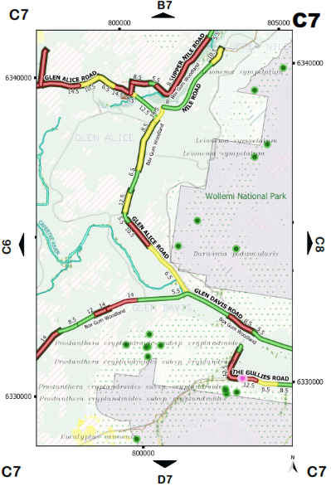
(example from Lithgow City Council RVMP field guide)

Roadside Environmental Management Priority Sites
Describe the process used to rank or prioritise roadsides for management.

! | Site prioritisation assists with determining where efforts and funding are best directed. High priority sites, in particular should be listed in the RVMP with a brief explanation of why and how they have been identified. Within these high conservation value areas, it is useful to prioritise the sites based on the range of assessment attributes.  For example, there may be some sites that have unique or significant attributes, such as a few remaining locations for threatened species that are under threat from urban development or other issues. An understanding of high priority sites is critical to council environmental decision-making and can also be used to determine priorities for rehabilitation.

An example of a system used to prioritise high conservation value sites was undertaken for Parkes Shire Council. In their case a resilience score was used to determine the recovery potential of bushland in sections of the road corridor. Development of a resilience score used an Assets versus Problems approach.
Assets were calculated from:
  - Vegetation Values (vegetation structure, presence of old/large trees, and corridor width),
  - Restoration Potential (groundcover nativeness and presence of tree seedlings), and
  - Habitat Values (logs, rocks, wetlands, creeks etc).
Problems were calculated from:
  - Weed Cover (woody weeds and groundlayer weeds) and
  - Road management issues.
The Recovery Score was then calculated by subtracting the total Problems score from the total Assets score.
  - Recovery Score = Total Asset Score – Total Problem Score
If the result was a negative value the roadside vegetation in that location has more problems then assets, and a very limited recovery potential. If the result was a positive value then the roadside vegetation in that location has a positive recovery potential. The size of the Recovery Score (positive or negative) gives a comparative indication of the recovery potential for each area of roadside vegetation.
A combination of Conservation Value (HCV, MCV, LCV) and Recovery Score was used to prioritise roads for rehabilitation work in roadside vegetation. Roads with HCV vegetation and a higher Recovery Score got the highest priority for ongoing maintenance. These were added to the shire’s list of Significant Roadside Environment Areas (SREAs) and were signposted at each end.

The SREA sign template can be used by councils to identify their high priority sites.
Other councils have used guidepost markers to provide information about roadside values or issues.
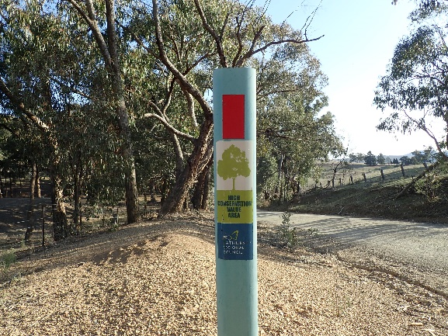
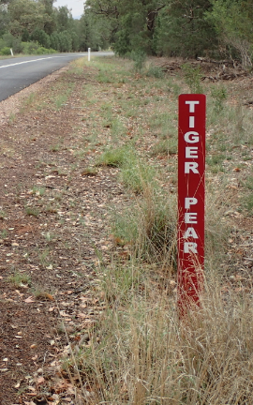
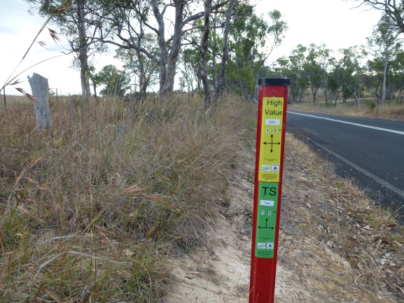
(left: HCV and threatened species marker (Mid-Western Regional Council); centre: Priority Weed (Tiger Pear) warning (Parkes Shire Council); right: High Conservation Value area (Bathurst Regional Council)).

Management Action Plan
Detail the management actions that will be undertaken to achieve the RVMP objectives.

! | Management actions should ideally be grouped under an objective, in an action plan table that succinctly identifies the action, which section(s) of council are responsible for delivering the action, delivery priority and indicative cost. Management actions may be ‘one-off’ or have an ongoing time period, for example, ‘establish and foster partnerships with other roadside environment stakeholders such as adjacent councils, Transport for NSW and the REC to share information and implement actions in this plan’ or ‘implement Council’s adopted roadside maintenance procedures for all operational works on high and medium priority areas.’

There are generally four main categories of actions emanating from a RVMP:
- Actions relating to legislative requirements for road construction and widening.
- Actions relating to other legislative requirements such as weed management, bushfire management.
- Actions to minimise the impacts of threats and resolve issues.
- Actions to better manage high, medium and low conservation value roadsides and, in particular, the high priority sites.
A comprehensive range of management actions, maintenance guidelines for high, medium and low roadside priority areas and information on roadside signage is provided in REC factsheet 3 Managing Roadsides – Implementation.
The management action plan could use the format outlined in Table 1 below.
Table 1: Management Action Plan
Action | Priority | Timing | Responsibility | Resourcing
List action from the four categories above | High, Medium, Low (based on urgency and importance) | When will the action be carried out (include an indicative time frame for each e.g. within two years, or five years or ongoing) | Which council department has the responsibility for the action? (This should be asset manager e.g. engineer/works department with advice from other departments/staff e.g. environmental/parks staff as required) | How will the action be funded and staffed? (capital works or recurrent funding)

! | A management plan that is based on the above template will look like the following table. Remember, if you have identified a threat or issue for roadside vegetation in your LGA you will need to find some type of action to address it. This may be straightforward, or more complex or time consuming depending on the nature of the threat or issue. Even for more unusual threats, in most cases someone else will have had to deal with something similar. Contact the environment staff at neighbouring councils, or at your Local Land Services office, or contact Local Government NSW. Sometimes the best results are achieved through a collaborative program across several LGAs, and these may have more success attracting grant funding to support the project.

Table 2: Example Roadside Vegetation Management Action Plan
Action | Priority | Timing | Responsibility | Resourcing
 | High, Medium, Low  (based on urgency and importance) | When will the action be carried out?  (include an indicative time frame for each e.g. within two years, or five years or ongoing) | Which council department has the responsibility for the action?  (This should be asset manager e.g. engineer/works department with advice from other departments/staff e.g. environmental/parks staff as required) | How will the action be funded and staffed?  (capital works or recurrent funding)
(1) Actions relating to legislative requirements for road construction and widening
Incorporate RVMP into council’s IP&R framework | High | Immediately, then ongoing
Inclusion of high priority roadside mapping and clauses in the council LEP or DCP | Medium | 3 to 5 years (next review)
Use REF template | High | Ongoing
Update RMS factsheets and environmental practice notes based on review (if your council uses them) | High | Annually, ongoing
Use Standard Operating Procedures (SOPs), site checklists, etc for capital works | High | Ongoing
Use Safe Work Method Statements (SWMS) or SOPs, site checklists, etc for routine road maintenance activities (slashing, grading, spraying, etc). Incorporate into daily machinery checklists | High | Ongoing
Ensure that SOPs or SWMS incorporate conservation signiﬁcance and appropriate management actions according to level of signiﬁcance | High | Ongoing
Internal training on environmental impact assessment triggers, environmental threats/issues specific to the council area and how to use the REF template | High | Repeat 3 to 5 years
Internal training on environmental threats/issues specific to the council area and how to use the RVMP plan, field guide, report cards, etc | High | Repeat 3 to 5 years
Plan construction work to minimise impacts | High | Ongoing
Regular review and updates to SOPs (minimum annually), etc to ensure ongoing compliance (eg following changes to legislation) | Medium | Annually, ongoing
(2) Actions relating to other legislative requirements, such as weed management, bushfire management
Establish council work priorities and procedures relating to priority weeds and bushfire environmental assessment codes in the LGA |  | 1-3 years
Liaise with local weed control authority to promote ongoing appropriate management of weeds in the road corridor for biodiversity and biosecurity outcomes
Monitor outbreaks of priority control weeds and implementation of a weed control strategy | High | Ongoing
Prioritise targeted weed management in roadside reserves or adjacent areas containing threatened species or communities, eg. Saving Our Species - Site Managed Species
Regular review and updates (minimum annually) to SOPs, etc to ensure ongoing compliance (eg following changes to legislation) | Medium | Annually, ongoing
Establish Council ‘Green Team’ – works crew that is primarily involved in restoration of natural areas, including roadside vegetation; fund through environmental levy and/or grant funding | Medium | 3 to 5 years, then ongoing
Ensure the roadside vegetation along bushﬁre prone roads and RFS preferred extraction routes is adequately maintained and kept clear in accordance with RFS and Councils bushﬁre exit strategy | High | 1 to 3 years
Develop a communications strategy outlining how to respond to requests from the public regarding clearing moderate and high conservation roadside vegetation to manage bushﬁre risk | High | 1 to 3 years
Community education about location of firebreaks (ploughed, slashed, mown, graded) – these must be on the property they are to protect, and not on the road reserve | Medium | 1 to 3 years
Lobby power supply companies and/or other utility companies to reduce the impacts of vegetation maintenance under power lines on Endangered Ecological Communities, eg through changes to the extent and frequency of clearing | Low | 3 to 5 years
(3) Actions to minimise the impacts of threats and resolve issues
Implement general guidelines/operational procedures to undertake sustainable roadside works relating to road construction, routine maintenance and the environmental management of weeds and bushfire threats | High | Ongoing
Rural community education about permissible activities in the road reserve – for example, ratepayer mailouts | Medium | 1 to 3 years
Establishment and implementation of penalties for infringements, eg through Council and/or DPIE | Medium | Ongoing
Active targeting of community groups and commercial entities to engage in roadside vegetation projects, eg. rubbish collection, revegetation planting, adopt a road programs, Landcare group site extension or adoption | Medium | 1 to 3 years, then ongoing
Licenced and targeted seed collection and propagation of plants for local revegetation projects | Medium | 1 to 3 years, then ongoing
Establish local native plant nursery to provide native plants to the community for their properties; educate landholders on the importance of local native vegetation; provide lists of ‘plant me instead’ species  34 | Medium | 3 to 5 years
Liaise with Local Land Services to reduce the extent of impacts from overgrazing and other activities requiring permits; where possible avoid grazing in HCV roadside vegetation | Medium | Ongoing
Develop a prioritised revegetation program to create vegetation corridors that act as linkages between core habitat areas | Medium | 3 to 5 years
Ongoing Roadside Vegetation Management training programs for Council’s outdoor staff, including road crews, parks and gardens, and stormwater management staff | High | Ongoing
(4) Actions to better manage high, medium and low conservation value roadsides
Conduct environmental assessment and roadside reserve prioritisation process of roadside environments | High | Immediate (this plan)
Development of a GIS database identifying roadside environmental priorities, which is updated as new information is collected | High | Immediate (this plan), ongoing
Internal Councillor and staff training to increase awareness on council’s natural assets/roadside environments and how to use and interpret the GIS database | High | Immediate (this plan), ongoing
Develop field guide/toolbox guide to summarise conservation value of roadside vegetation in the LGA; include identification of threatened communities and species, priority control weeds, etc; include SOPs or SWMS for each conservation value category, site management checklists, etc | High | Ongoing
Site toolbox talks to identify potential conservation values and problems in the area; consider use of road report cards or similar as part of daily works information packages | Medium | Ongoing
Staff training in the use of tablets to access the GIS database and upload information in the field | High | Ongoing
Roadside signage (Significant Roadside Environmental Area signs, roadside markers, etc) identifying high priority environmental features | Medium | 1 to 3 years
Use Significant Roadside Environmental Areas (if your council has them) as focal points for restoration activities such as environmental weed control, erosion control, litter removal, revegetation if required, etc | Medium | 1 to 3 years
Liaise with RFS to use ecological burns to stimulate regeneration growth in MCV and HCV areas; ensure there is adequate resources available for follow up weed control in these areas. | Low | 3 to 5 years
Implement road maintenance works actions as described in the Standard Operating Procedures | High | Ongoing
Link management of native vegetation to other outcomes, eg capital works, European and Indigenous heritage items and places | Medium | Ongoing
Subscribe to the REC Newsletter, produced quarterly by the Roadside Environment Committee | Medium | Ongoing
Identify areas of frequent dumping in the roadside and install signage advising of surveillance and penalties | High | 1 year
Install signage in areas of high conservation signiﬁcance to highlight the values of these areas to road workers and the community | High | 1 year
Management of areas disturbed by works in the roadside reserve should be rehabilitated using suitable plant species and planting densities and incorporation of habitat such as large woody debris, hollow augmentation and reuse of bush rock. A guide to current best practice is available at http://www.rms.nsw.gov.au/business-industry/partners-suppliers/documents/guides-manuals/biodiversity_guidelines.pdf | Medium/High | Ongoing
Develop a concise summary of the RVMP which outlines the purpose of the document and how it will be used to inform council on appropriate management of roadside reserves with moderate/high conservation signiﬁcance | High | 1 year
Develop restoration plans for priority roadside areas that act as biodiversity corridors across the landscape. Restoration plans should consider factors such as conservation signiﬁcance, landscape connectivity, threatened species and amenity to the general community | Medium | 3 to 5 years
(5) Allowable activities on high, medium and low conservation value roadsides
Permissible activities in high conservation value roadsides include bush regeneration, weed control and remediation of impacts from road construction works | Medium | Ongoing
Permissible activities in medium conservation value roadsides include weed control and revegetation to link HCV areas; grazing may be permissible when compatible with management aims, but avoid camping and corralling of stock and avoid grazing during spring flowering and summer seed set | Medium | Ongoing
Permissible activities in low conservation value roadsides include grazing during drought, power and phone line installations, roadwork stockpile sites, machinery parking, weed control, including boom spraying. However, care must be taken not to over clear in areas that may be susceptible to erosion | Medium | Ongoing
Activities that are not permitted include firewood collection, ploughing or other activities for firebreaks, bushrock removal and other activities identified as key threatening processes under the Biodiversity Conservation Act 2016 | High | Ongoing

Your management action plan can refer to other documentation within a more holistic Roadside Vegetation Management Plan package, for example:
  - Review of Environmental Factors (REF) templates for major projects, minor works and routine activities such as shoulder grading and mowing/slashing of unsealed roads
  - Standard procedures for site establishment and shutdown
  - Standard procedures for routine maintenance activities
  - Roadside Vegetation Management Policy (this can be embedded in the RVMP or as a separate document)
  - Standard procedures for identifying HCV and MCV areas in the field
  - Standard procedures for reporting threatened species, priority weeds, etc
  - Register of Natural Assets for the LGA
  - Field Guide/Toolbox Guide with mapping of roadside vegetation in the LGA and information for identification of threatened species and vegetation communities
  - Action plans for priority restoration sites
  - Landholder information sheets, field information days, etc.

Monitoring and Evaluation
Monitoring and evaluation should be conducted for the:
  - vegetation condition and environmental assessment processes
  - RVMP itself
  - implementation of management actions
Councils need to decide the extent and location of the roads to be assessed for vegetation condition, and how frequently this should be updated.
Some questions for directing the process of monitoring are provided below.
!
Guidance for monitoring and evaluation is provided in the CREMF overview report and the REC factsheet 4 Managing Roadsides: Monitoring and Evaluation.

Monitoring the implementation of actions
The success of the RVMP action plan should be reviewed on an annual basis. Key points to consider in evaluation are (adopted from Queanbeyan-Palerang Regional Council RVMP):
  - Appropriate maintenance of roadsides - How is maintenance quality being monitored? Is a community complaints register being used? Is the maintenance regime appropriate to the conservation value status of the roadside? Is it effective and efficient?
  - Training - Based on training feedback sheets and works outcomes, was the training appropriate and effective? Has it left a lasting legacy of best practice? When will the training program need to be updated and when will participants need to update their training?
  - Regulation - Are enforcement activities working? How well are they being coupled with community education?
  - Stakeholder engagement and partnerships - Are those being engaged still appropriate? Are there partnerships in place to effectively implement the management actions? How are these partnerships maintained?
  - Funding opportunities - Are funds such as grants and sponsorships being sought? How successful has council been in obtaining funding? What are the critical success factors and what are the barriers to obtaining internal and external funding?
  - Restoration and rehabilitation projects - Have the planned project outputs and outcomes been achieved? If not, why not? Have these funded projects/programs been completed to deadline, within budget? Were there any unexpected outcomes? How will the project outputs be monitored and evaluated in the future to ensure that they are still in place? What learnings and improvements are there for future projects?
  - Community education - From community feedback such as a survey, is the community aware of the importance of roadsides and particularly those of high conservation value? Has there been a reduction in illegal behaviour (dumping, littering, firewood collection) as a result of the community education actions?
  - Signage and markers - Is the signage or markers effective in encouraging best practice or changing target behaviours among council staff/contractors and the community?

! | Answers to these questions provide the basis for annual reporting and will assist with informing the content of the Operational Plan (see Section 5: Links with Council systems and planning).

Monitoring the RVMP
To maintain the efficacy of the RVMP it also needs to be monitored and updated. Key questions to consider when evaluating and revising the RVMP include:
Vision. Is this still appropriate?
Objectives. Are these still appropriate and consistent with Council’s environmental objectives?
Relevant legislation. Is there new, repealed or amended legislation? If so, what impacts will it have on the RVMP and its implementation?
Links with Council systems and planning. Are the links between the RVMP and Council systems and planning still in place? Can they be revised as conditions change, or be better formed?
Description of roadside vegetation and other environment values. Are there changes as a result of the monitoring and evaluation and assessment as described above?
Local roadside environmental management threats and issues. Have the threats and issues changed? If so, what impact have they had on local roadside environments?
Community interests, values and activities. Have community values, attitudes and behaviours regarding roadside environments changed? If so, what impact will this have on actions in the RVMP and their implementation?
Conservation values. New information such as listings of Threatened Species may change the conservation value status of roadsides, prompting an amendment of that section of the RVMP and possibly resultant actions. An overall re-assessment within ten years will trigger a revision of the RVMP. This also aligns with development of the next CSP to reflect community values and expectations.
Roadside environmental management priority sites. As for the conservation value status, new information should be monitored and amendments to the RVMP conducted to prioritise projects and programs in high conservation value areas.
Management action plan. This may need to be amended in light of the responses to the above questions.

Appendix

